Control Coupling

📌 Definition:
# Source: AI Source: Provided by: [Data Path: Persons Table -> ID Column: 1, Name_En Column: Motasem Essam] -> From: [Chatgpt (GPT‑5 Mini)] on [12/9/2025]
Control Coupling occurs when one class/module passes control information (flags, decisions) to another, influencing how it behaves internally.

🧠 Simple idea:
# Source: AI Source: Provided by: [Data Path: Persons Table -> ID Column: 1, Name_En Column: Motasem Essam] -> From: [Chatgpt (GPT‑5 Mini)] on [12/9/2025]
“One module tells another module what to do” ⚠️

🔍 Key characteristics:
# Source: AI Source: Provided by: [Data Path: Persons Table -> ID Column: 1, Name_En Column: Motasem Essam] -> From: [Chatgpt (GPT‑5 Mini)] on [12/9/2025]
- One module controls the flow of another module
- ❌ Leads to tight dependency on internal logic
- ❌ Can reduce modularity and maintainability
- ⚙️ Can be reduced by encapsulation and polymorphism

📊 Example of Control Coupling (Bad Practice):
# Source: AI Source: Provided by: [Data Path: Persons Table -> ID Column: 1, Name_En Column: Motasem Essam] -> From: [Chatgpt (GPT‑5 Mini)] on [12/9/2025]
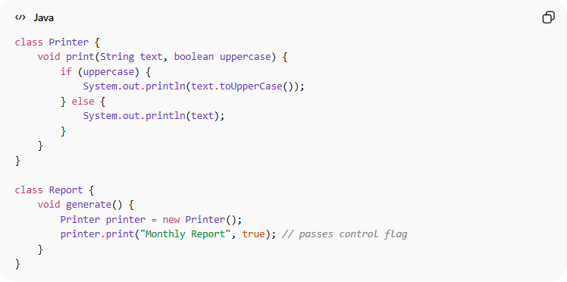
class Printer {
void print(String text, boolean uppercase) {
if (uppercase) {
System.out.println(text.toUpperCase());
} else {
System.out.println(text);
}
}
}

class Report {
void generate() {
Printer printer = new Printer();
printer.print("Monthly Report", true); // passes control flag
}
}
- ✅ Report decides how Printer behaves using a flag
- ✅ Printer behavior is dependent on external logic, reducing modularity

🛡️ Avoiding Control Coupling Example:
# Source: AI Source: Provided by: [Data Path: Persons Table -> ID Column: 1, Name_En Column: Motasem Essam] -> From: [Chatgpt (GPT‑5 Mini)] on [12/9/2025]
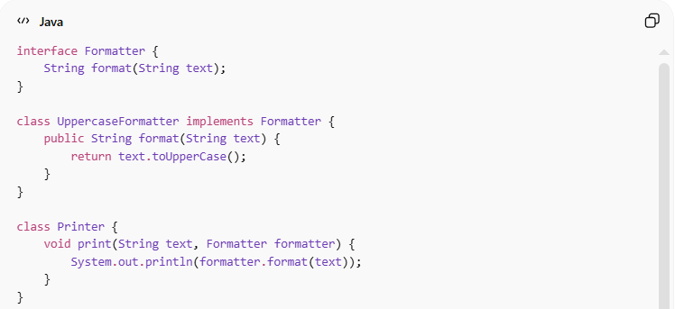
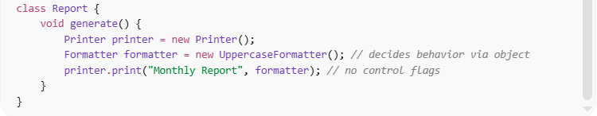
interface Formatter {
String format(String text);
}

class UppercaseFormatter implements Formatter {
public String format(String text) {
return text.toUpperCase();
}
}

class Printer {
void print(String text, Formatter formatter) {
System.out.println(formatter.format(text));
}
}

class Report {
void generate() {
Printer printer = new Printer();
Formatter formatter = new UppercaseFormatter(); // decides behavior via object
printer.print("Monthly Report", formatter); // no control flags
}
}
✅ Key improvements:
- Printer does not rely on flags or external logic
- Behavior is determined via polymorphism/abstraction
- Improves flexibility, modularity, and maintainability

⚙️ Best Practice:
# Source: AI Source: Provided by: [Data Path: Persons Table -> ID Column: 1, Name_En Column: Motasem Essam] -> From: [Chatgpt (GPT‑5 Mini)] on [12/9/2025]
- Avoid passing control flags to methods
- Use polymorphism, strategy pattern, or callbacks instead
- Keep modules focused on their own behavior
- Reduces tight coupling and unexpected dependencies

